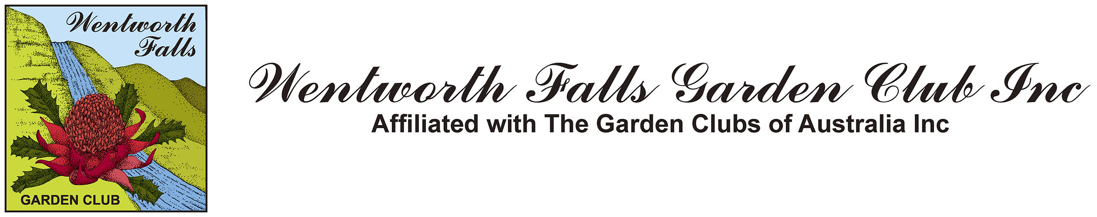
13th March 2014 Edition No. 269

FromThe President…….

It seems that we are now over the heat of summer and can look forward to the wonderful autumn colours as they develop over the next few weeks. This is one of the joys that we have of living here in the Blue Mountains.
As mentioned over the past few months, a Subcommittee has been meeting to revise the Constitution of the Club to reflect its current activities. A draft is now available for your consideration on the club website, www.wentworthfallsgardenclub.com. Please take the time to read it and, if you want, make any suggestions or comments to members of the Committee during March and April. This will then be presented for final approval at the Annual General Meeting, which is held as part of our General Meeting on 8 May.
At that meeting we will also elect a new Committee for 2014-15. Most members of the current committee of willing volunteers are renominating for their positions but there will be some new faces on the Executive as Janice, Michael and I leave our current roles.
With the retirement of Sylvia Smith, we need replacements now for her roles in convening the Plant Stall and in presenting Garden Tips, and I am pleased that Corrie Kennedy, one of our newer members, has offered to help with tips each month. However, we still need volunteers for the plant stall which allows members both to share their plants and to stock their growing gardens month by month. Please speak to us today if you can help in this role.
We welcome visitors to our meeting, and invite you to apply for membership if you feel that this Club is the one for you.

Good Gardening.

Henry

Klaus will talk on his views about how roses fit into gardens, how the plant works and how to look after them.
The Guest Speaker for today is Klaus Eckardt.
Klaus has been involved with roses all his life and his parents had the Highland Rose Nursery, Dural. He established Green E Roses, Galston, in 1982. It started as a general nursery producing all kinds of plants, ranging from natives to roses.
Initially roses were grown in the ground, dug up in winter for bare rooted sales, and any leftovers potted up to sell during the year. As the business grew and production methods changed from growing roses in-ground to growing them in containers, they specialised in growing roses only, as they could now be sold year round.

Green E grow:
Modern Roses. Many of the hybrid and floribundas are also available as standardised plants.
David Austins. 85 varieties currently available. Most are fragrant and repeat flowering.
Delbard Roses. Known internationally for their extraordinary roses that perform well in our climate.
Alister Clark Roses. Historically valued Australian bred roses well suited to our conditions.
Old World/Rugosa/Moss roses. 150 varieties available and are a must for any rose lover.
Thornless. Large flowers, no thorns, repeat flowering – more beauty, less beast.
Weeping Standards. Large variety of 4’ to 6’ accent plants available.

Dates for Your Diary

Saturday  12 April | The 9th Plant Collectors’ Fair, Hawkesbury Race Course, Richmond. Early start with plenty of time to browse and shop, then a light lunch, at the Norman Lindsay Gallery. | Cost  $38 | Departure 7am
Friday  11 April | Autumn Garden Ramble. Address to be advised. | Nil cost | 10.30am
Friday  9 May | The Australian Plantbank. We have had many requests for this outing. The cost includes the guided tour of $16. Lunch will be at Melaleuca House where we have previously enjoyed a lovely lunch. There may be a stop at Flower Power for some retail therapy before heading home. | $42 | Departure 9.30
Friday, 12 September | Overnight trip to Berry for their 25th Open Garden Anniversary. We will view some amazing gardens. A $50 deposit per person is required. | Cost TBA | Departure time TBA
Saturday  25 October | Bathurst Spring Spectacular. | Cost TBA | Departure time TBA
Thursday  4 December | Christmas Party at Wentworth Falls Country Club | Cost TBA | 12 noon

Cost of tours this year will reflect the increase of fuel & hire of coach.
Guest Speakers
Today’s Meeting  13 March:  Next Meeting:  10 April: | Klaus Eckardt Nurseryman from Green E Roses  Angus Stewart  Horticulturalist, Author, T.V. Presenter and Broadcaster  “Western Australian Wildflowers”

Club Information
All members and visitors are asked to sign in upon arrival.

Members are asked to wear their club name badges to all club meetings, tours and functions. To take part in club functions and tours you must be a bona-fide club member.

General Meetings are held on the 2nd Thursday of each month, from January to November at the Wentworth Falls School of Arts Theatre, Adele Ave (cnr Great Western Hwy) Wentworth Falls. Meetings commence at 9.45 and finish around noon. The Library and Plant Stall are open before the meeting and at morning tea. $5 entry fee.

Joining fee is $30. Thereafter annual subscription is $20.

For Club Welfare matters contact Jane McKanna on
Ph: 4787 8631.

Morning Tea
Today: Vivien Jones & Silvia Ikaunieks

10 April: Bernadette Heckford & Christine
Caton

If you are unable to come on your rostered day, please call Jane Blackshaw on 47572887
Club Secretary:
Janice Light. Ph: 4782 2481
Wentworth Falls Garden Club, PO Box 37
Wentworth Falls NSW 2782
www.wentworthfallsgardenclub.com

