Jenny met us and provided background information. Jenny said that they do not hire gardeners and that she and Peter do the hard work. When we were there she was scooping compost onto garden beds.

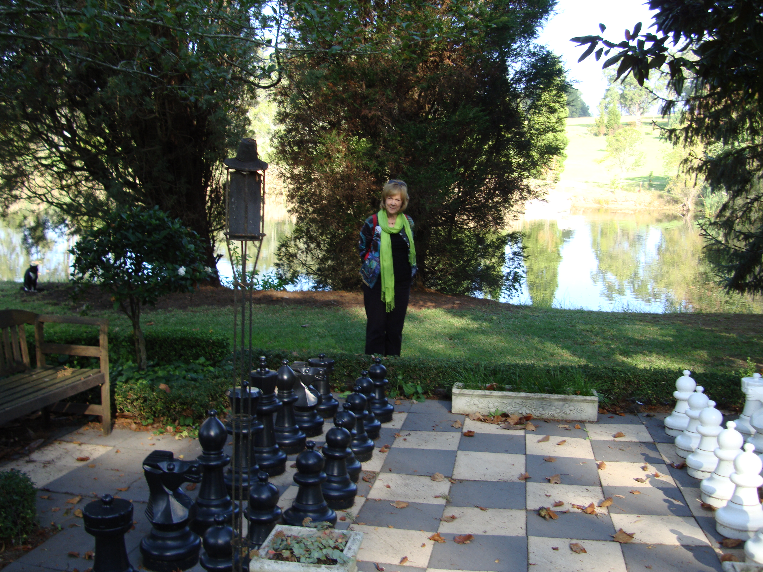

Guestlands garden has many features including a large dam that sits at the bottom of the gently sloping property.
 Dates for Your Diary
The formal area features extensive stonework and a colonnade walk covered in New Dawn roses. From the oriental garden at the top of the property, a stream passes through several ponds full of goldfish, flowing across stones on its path down the hill into the dam. There are roses, lavenders, iris and a wide range of shrubs and perennials beneath mature deciduous trees. The older area has some wonderful mature Japanese maples.

Photos:
pge 1 left…. Lizzy and Gai - the café at Geranium Cottage
right…Nancy, Lynton and Sharon - oriental garden
Guestlands
pge 2 Gai - the lawn chess set, Guestlands

Thank you to Sharon and Lynton for planning and organising this trip.

Friday  12 July | The Charm of Camellias | A tour of beautiful camellias on Yowie Bay. Lunch then home. More details soon. Names and money will be taken today for this trip. | Cost  $35 | 9am sharp departure
Friday  20 Sept | A Walk on the Wild Side | We will tour the stunning Wildwoods Gardens in the heart of Bilpin. Lots to choose from for lunch. There is also a tearoom, gift shop and nursery to browse through. | Cost  $35 | 9am sharp  departure and 9.20 pick up at Blackheath

Annual subscriptions to the Wentworth Falls Garden Club are due. The cost $20.
Contact Jane McKanna on Tel 4787 8631 for club member welfare.
Club Information
All members and visitors are asked to sign in upon arrival.

Members are asked to wear their club name badges to all club meetings, tours and functions. To take part in club functions and tours you must be a bona-fide club member

General Meetings are held on the 2nd Thursday of each month, from January to November at the Wentworth Falls School of Arts Theatre, Adele Ave (cnr Great Western Hwy) Wentworth Falls. Meetings commence at 9.45 and finish around noon. The Library and Plant Stall are open before the meeting and at morning tea. $5 entry fee.
Guest Speakers
Today’s Meeting
13 June:

Next Meeting:
11 July:
Luke Eather from Cut Above Garden Tools

Ingrid Nemetz Hellebores

Morning Tea
Today: Gai Horrocks & Michelle Funnell

11 July: Adrienne Brown & Gail Schwedler
If you are unable to come on your rostered day, please call Jane Blackshaw on 47572887
Club Secretary: Janice Light. Ph: 4782 2481
Wentworth Falls Garden Club, PO Box 37
Wentworth Falls NSW 2782
www.wentworthfallsgardenclub.com

