From the President…
Last week we held our monthly Committee Meeting (and morning tea this month!), to which all members were invited, and it was good to see some new faces there. As mentioned last month, there will be some vacancies on the committee which will need to be filled in 2013.
Narelle Nolan has agreed to take on the Publicity role from the beginning of 2013, replacing Michelle Funnell, who has done such a good job for the club over the last five years. We are thankful that Anne Tout and Celeste Shadie have now also joined the committee, and look forward to their contribution to the running of the club. Jane McKanna is continuing in her role as Welfare Officer, although she is leaving the committee. Please keep her (or any Committee member) informed of any people needing help in this regard.
As mentioned last month, Janice has decided to step down from the Secretary’s role after the next AGM and we will need to fill that position from May 2013. Additionally, Barry Butler will be vacating his role in the Library after the next AGM and will need to be replaced from among our members. Fortunately, he is willing to continue with computer work relating to membership which he has been doing up till now.
Please consider what task you could assist with in the operation of our club. As mentioned previously, about 23 people are needed to maintain the club activities, and allow it to continue month by month.
Good Gardening

Henry  

All members and visitors are asked to sign in upon arrival on the attendance sheets in the foyer.
 Morning Tea

Today: Jennifer Wigan and Barbara Boyle
January 10th: TBA
If you are unable to come on your rostered day, please call Jane Blackshaw on 4757 -2887

A reminder - there is a $2.00 per person contribution for morning tea

Meetings: General Meetings are held on the Second Thursday of each month, from January to November
Where: Meetings are held at the Wentworth Falls School of Arts Theatre, Adele Avenue (cnr of Great Western Highway), Wentworth Falls
When: Meetings commence at 9:45 am and finish at approximately 12:00 pm. The Library and Plant Stall are open before each meeting. There is a break during each meeting for morning tea.
Today’s Meeting | 8th November 2012
Speaker: | David Kennedy
Topic: | Woodland Plants
Next Meeting: | 10th January 2013
Speaker: | Megan Holcroft
Topic: | Bees
Members are asked to wear their club name badges to all club meetings, tours and functions.
Please remember that to take part in club functions and tours you must be a bona-fide club member
Wentworth Falls Garden Club
PO Box 37
Wentworth Falls NSW 2782
www.wentworthfallsgardenclub.com

Club Secretary: Janice Light Tel: 4782 2481
Printed by Wentworth Falls Newsagents
24 Station Street, Wentworth Falls
Tel: 4757 1211

 Dates for Your Diary
Other Garden Events
 | 17th – 18th November
 | “Clover Hill”, 82 Camp St, Katoomba
 | Late Spring display this is our best time of the year
Wentworth Falls Garden Club Events
 | Thursday/Friday 8th/9th November
 | Moss Vale Trip today
 | Christmas Lunch (see details)
 | Thursday 6th December
Something to put in your diaries for next year
 | Friday February 8th, Eusdale, stroll along the summer borders and then enjoy lunch on the shady verandah. Plants for sale, nursery on the way home, cost to be confirmed.
 | Friday March 15th, A Double Delight Day of Roses, rose farm tour, lunch and roses, cost to be confirmed.
 | Friday April 13th, Bilpin Plant Fair with lunch on the way home, cost to be confirmed.
 | Friday July 12th, The Charm of Camellias, tour and lunch, cost to be confirmed.
Raffle Prize
Arthropodium cirratum
Common name: Pink stars
An original water colour by Sylvia Beresford
1 ticket for $2 or 3 for $5
Thank you again Sylvia for your generosity to our garden club
Raffle to be drawn at Christmas Lunch
 Christmas Lunch
When: Thursday 6th December
Where: Wentworth Falls Country Club
Time: 12 noon
Cost: $32 pp
Traditional buffet lunch, desserts, glass of wine/juice, tea/coffee
Lucky Door Prizes
Major raffle prize draw of an original water colour by Sylvia Beresford
Finding a spot to grow vegetables
Many gardens have places which can easily be converted into an attractive and productive vegetable garden. Most people would put good soil at the top of their list of essentials. You can improve poor soil but you cannot change the position of the sun. Full sun light is ideal – sun for half to two-thirds of the day is essential.
If appearance bothers you why not enclose the vegetable area with a small, neat hedge of herbs such as rosemary, thyme or sage? Some gardeners surround the vegetable plot with low-growing annuals: the petite marigold is not only decorative but useful, for it will repel nematodes (the root-damaging eel worms).

Alan Seale, Our Gardens 1999
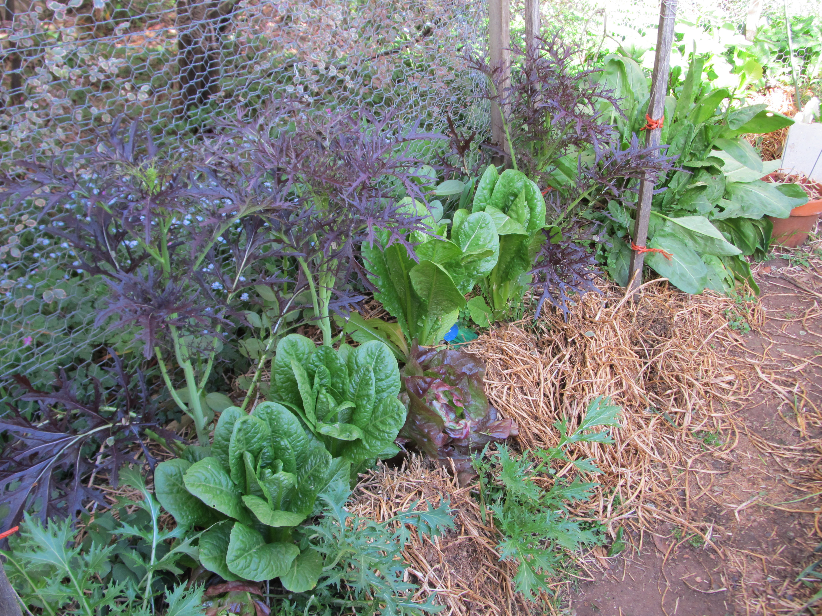
Contact Jane McKanna on Tel 4787 8631 for club member welfare
Be sure to look at the Grower’s Calendar for 2013, ask Janice Light if you are interested to purchase one. A great buy at $10 and a wealth of information.

