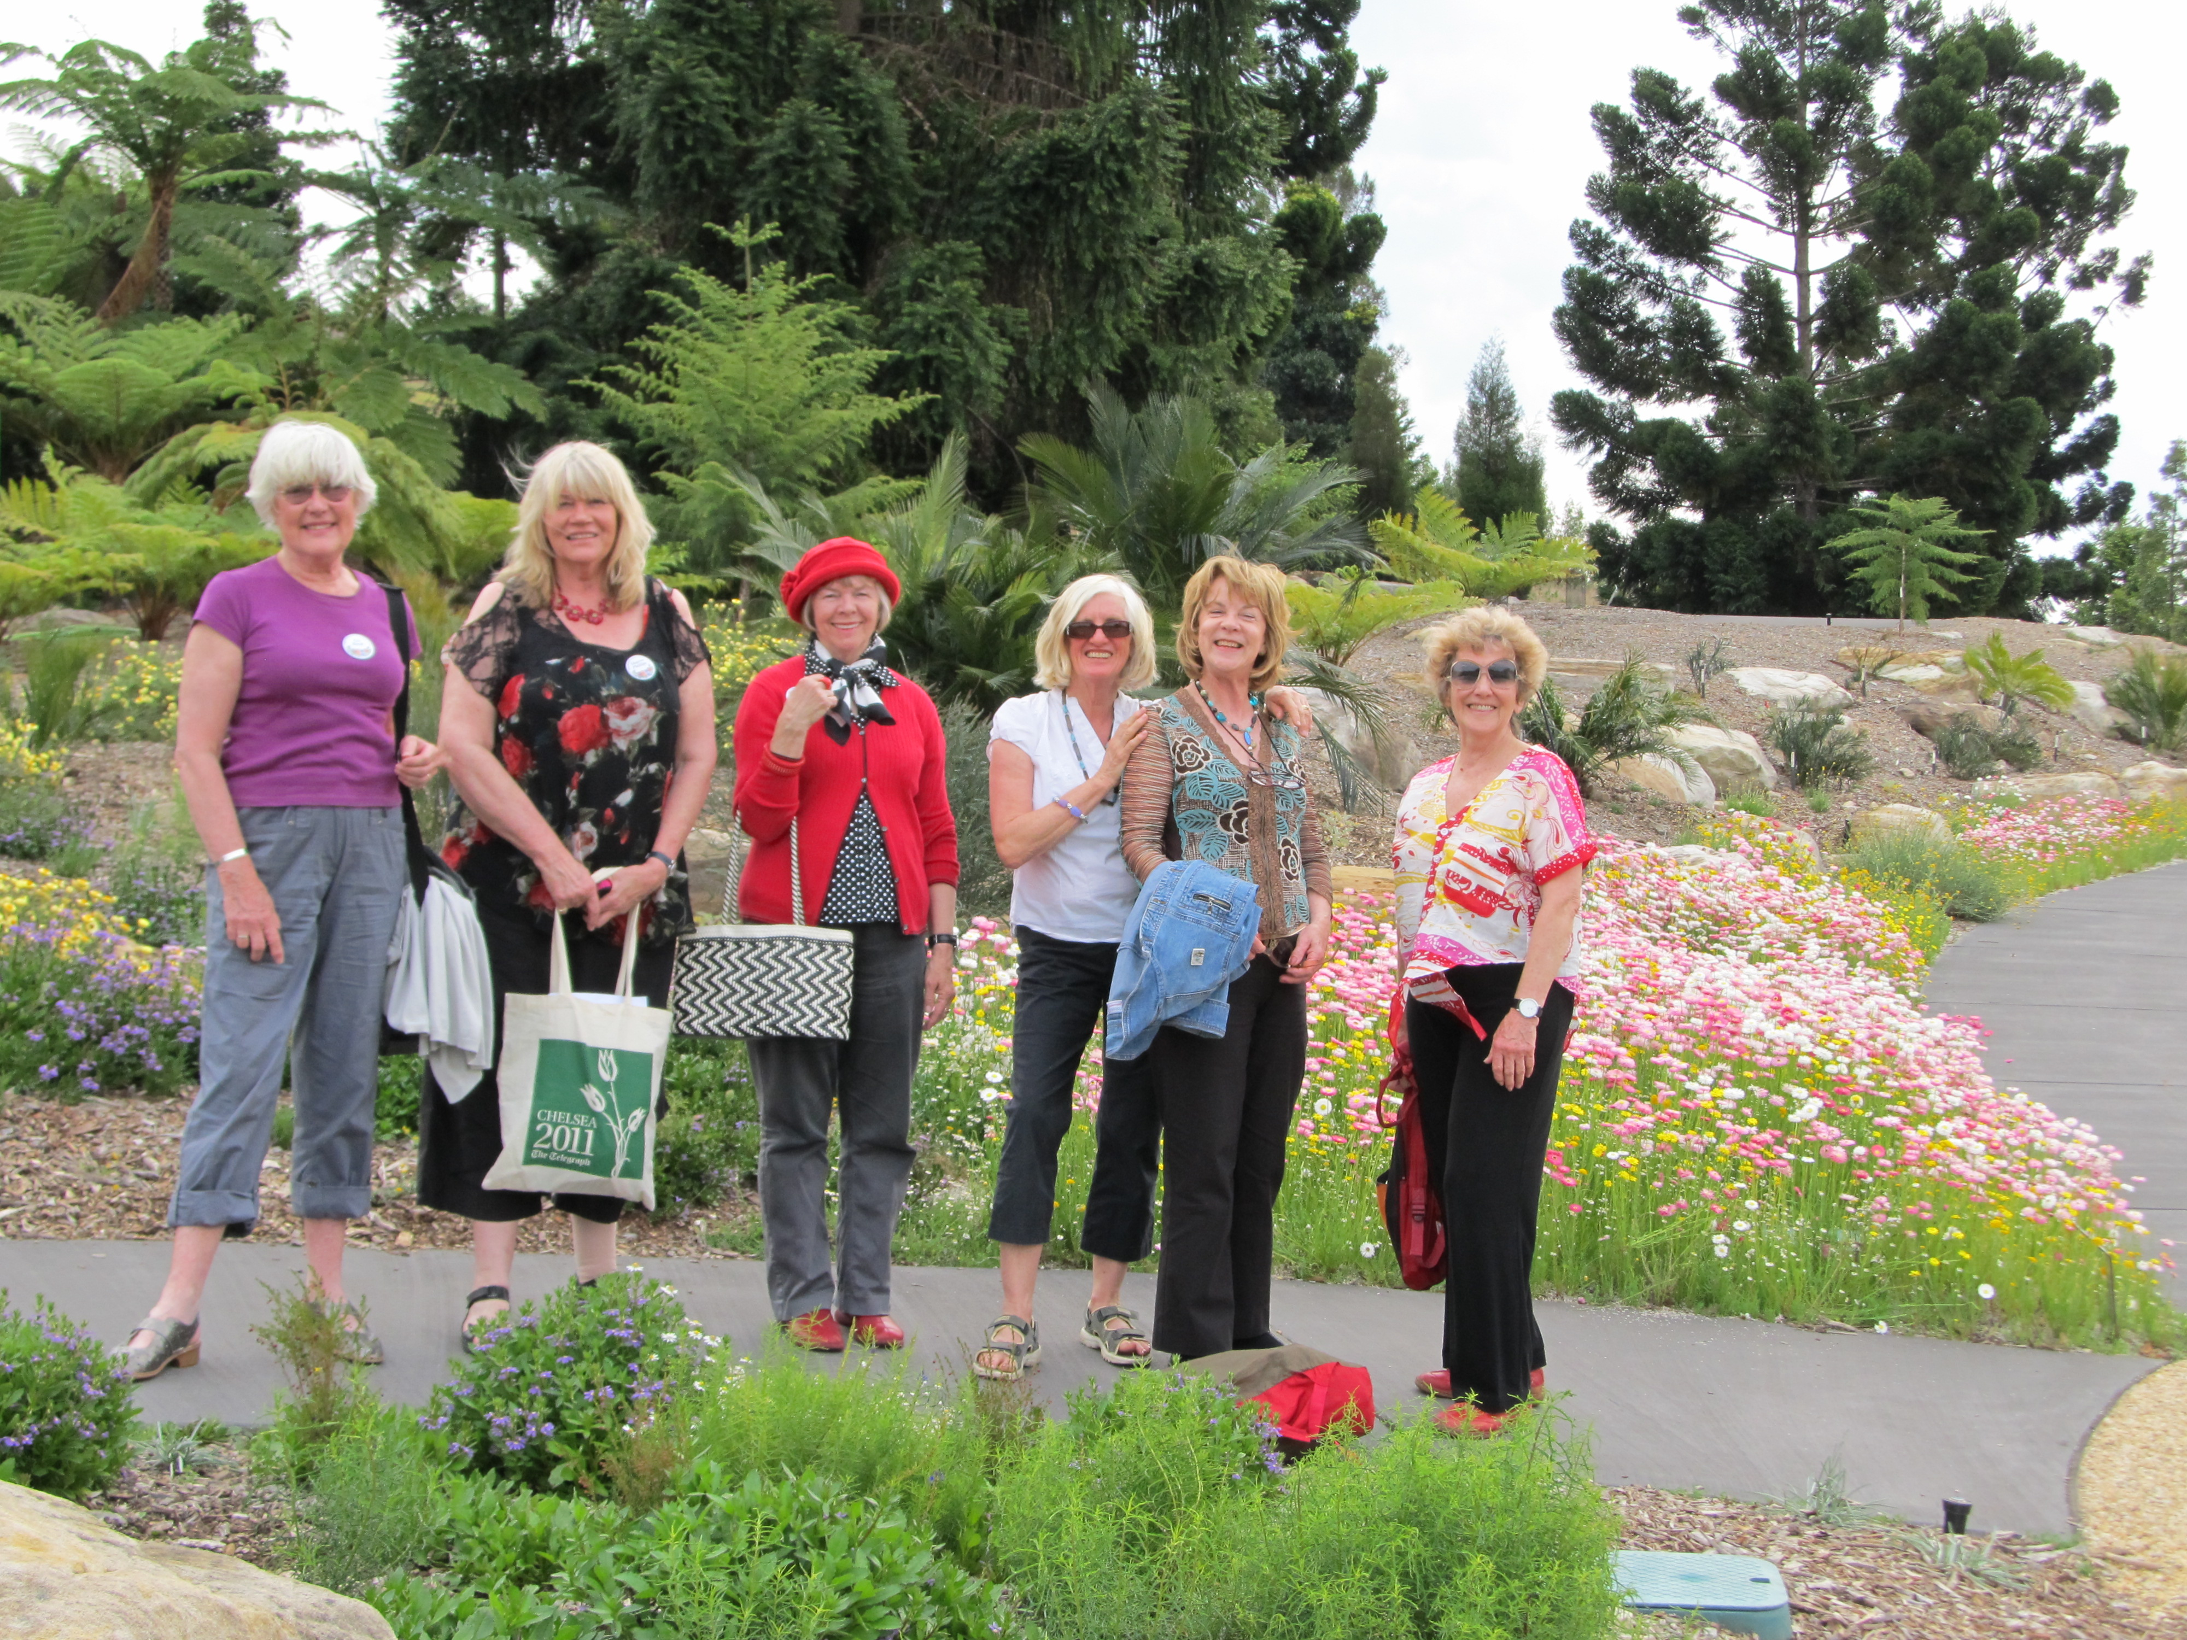
Newsletter pic: WF Garden Club Day trip to Mt Annan Oct 2012.

